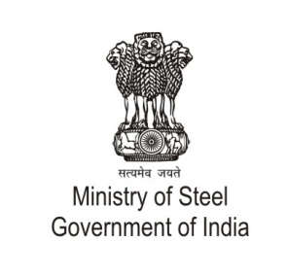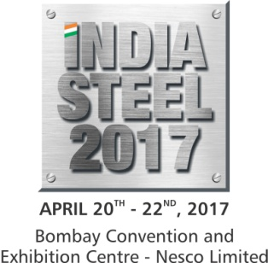

Annexure
Exhibitors’ Profile
Steel Industry Stakeholders
- Metal producing companies
- Alloy manufacturers
- Ferrous and Non-ferrous metal production plants and units
- State Governments
- Central Government Ministries

Machinery & Technology for Steel & Metal Manufacturing
- Domestic and International Steel Producers, Organizations & Associations
- Automation & Instrumentation
- Cutting Tools
- Water & Pump Equipments
- Welding Equipment & Services
- Control & automation Systems
- Quality Control, Testing & Analysis
- Energy Efficiency Equipment
- Energy Conservation
- Engineering and Design
- Environment protection
- Filtration & Separation
- Induction Furnaces and Heat Treatment
- Nano-Technologies
- Pelletisation
- Project Management & Consultation
- Pumps & Valves
- Refractories
- Safety Equipment & Technology
- Scientiﬁc Research & Development
- Scrap Collecting and Recycling
- Sheet metal, tube, section (ferrous and non-ferrous)
- Sintering
- Smelting and Reﬁning
- Software technology
- Foundry Engineering Units

Machinery & Technology for Mineral Mining & Processing
- Domestic & International Mining Companies
- Air Pollution Control Equipment
- Communication System & Technology
- Crushers, Diesel Engines & Grinding Mills
- Conveyor Belting & Components
- Cranes, Forklifts & Trucks
- Drilling and Crushing
- Earth Moving Equipment and accessories
- Environment & Geology and Mining Related Services
- Power Generation & Transmission Equipments
- Fans and Dust Collectors
- Locomotives, Lubricants & Greases
- Mines Safety Equipment
- Process Control Systems
- Rock Drilling Equipment
- Mineral Evacuation Machinery Manufacturer
- Safety Equipment & Technology
- Explosives, Drilling & Blasting
- Earthmoving, Construction Machinery & Lighting
- Information Technology Providers
- Logistics Supporters
- Environmental Protection Technology
- Material Processing & Handling Equipment Manufacturers
- Measuring & Testing Vendors
- Material testing agencies
Metallurgical Equipment & Technology
- Foundry Machinery & Technology
- Welding Equipment &Technology
- Rolling Mill equipment

Minerals
- Mineral Development Corporations
- Minerals Exploration Technology
- Handling & Processing
- Transportation and Logistics

Metal Machinery & Technology
- Bearings & Shafts
- Cutting, Shaping, Bending & Welding
- Consulting Design & Service
- Extrusion
- Finished products, components, assemblies
- Flexible sheet metal working
- Forging, Casting equipment and accessories
- Foundry Engineering
- Furnace and Heat Treatment
- Gears, Motors & Compressors
- Joining, fastening
- Lapping
- Laser Cladding
- Lubricants
- Machine Tools and Dies
- Polishing
- Spray Painting Systems
- Surface Treatment & Corrosion Technology
- Tube / Section processing
- Vibrator De-burring Machines & Consumable
- Shaping Equipment
- Signalling Equipment

Buying and Sourcing Mineral Processing
- Mineral Development Corporation
- Mineral Processing Units
- Contractors
- Scientiﬁc Research & Development Institutions
- MSMEs and Private companies

Buying and Sourcing of Metal & Metal Working Machinery
- Casting, Forging and Foundry Industry
- Component Manufacturers
- Consulting Service providers
- Iron and steel production
- Non-Ferrous Metals Production
- Sheet metal fabricators
- Sheet metal products, components, assemblies manufacturers
- Shipbuilding and Ship Repair Industry
- Steel & Aluminum Construction
- Tube and Pipe Sector
- Water Supplier Sector
- Trucks, Wheels & Tyres

